PYTHON PROGRAMMING

**CA2 TOPIC: PING PONG GAME**

**DESCRIPTION**

WHAT IS PING PONG GAME :

PONG IS A TABLE TENNIS-THEMED TWITCH ARCADE SPORTS VIDEO GAME, FEATURING SIMPLE TWO-DIMENSIONAL GRAPHICS, MANUFACTURED BY ATARI AND ORIGINALLY RELEASED IN 1972. IT WAS ONE OF THE EARLIEST ARCADE VIDEO GAMES

* **PING PONG GAME IN PYTHON PROGRAMMING**

The ping pong game is one of the most famous games of arcadia, which is quite similar to table tennis. The rules of this game are simple

* There are two players.
* Both have control over the paddle of their side.
* They can move the paddle on vertical sides from up to down and down to up.

Players can strike back and forth on the ball by using the paddle.

**Turtle**: The turtle is a built-in module in Python which is used for graphical illustrations. The users can use it as a pen and panel to illustrate the graphics

CODE:

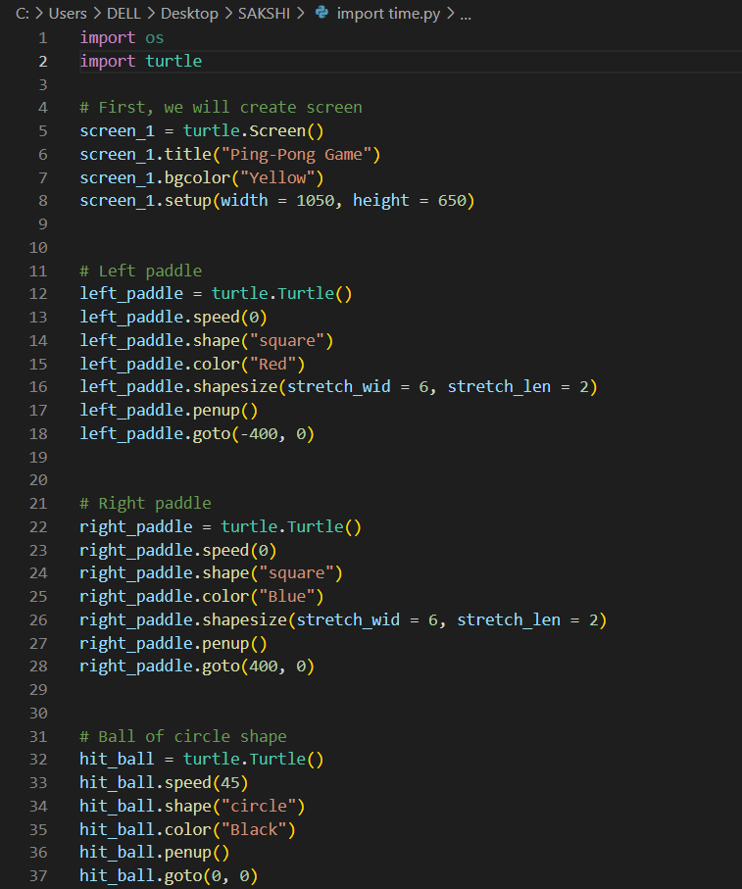

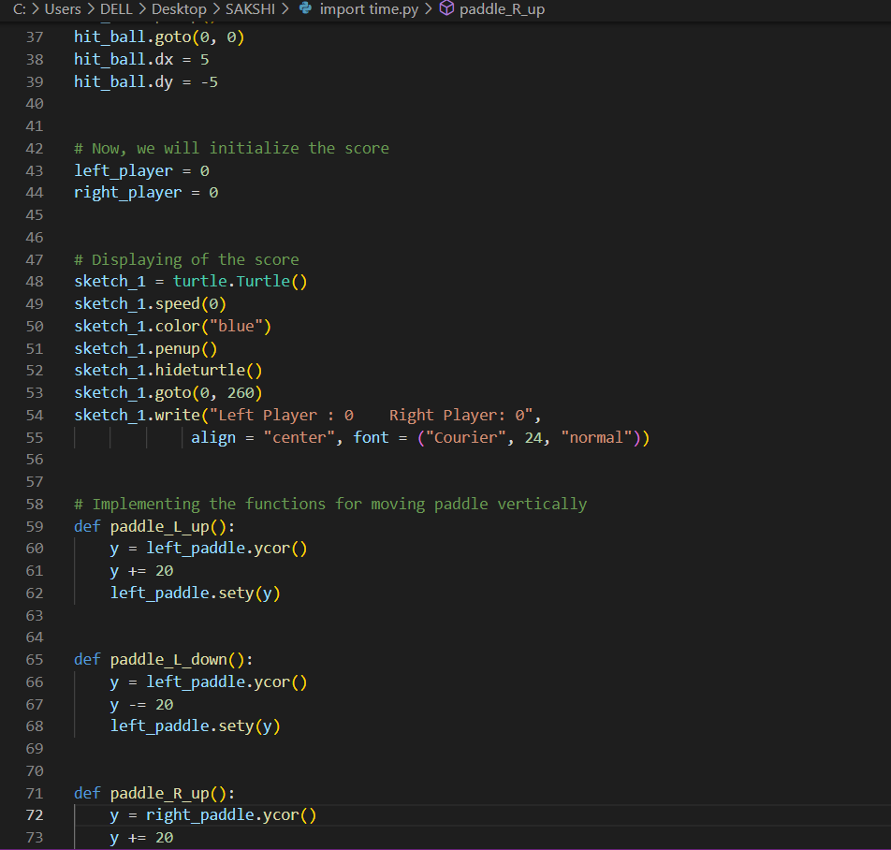

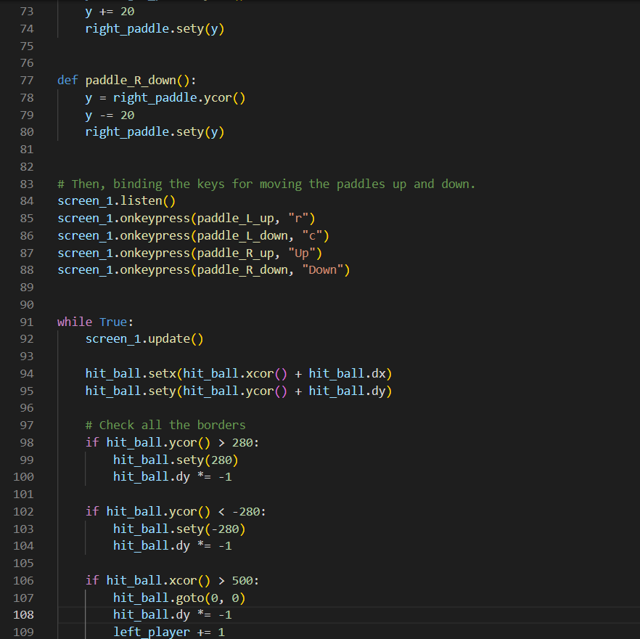

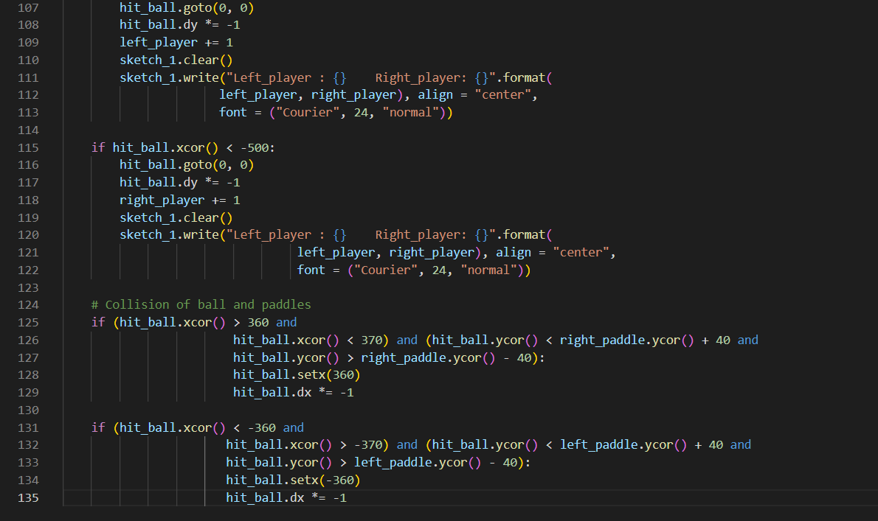



Output:

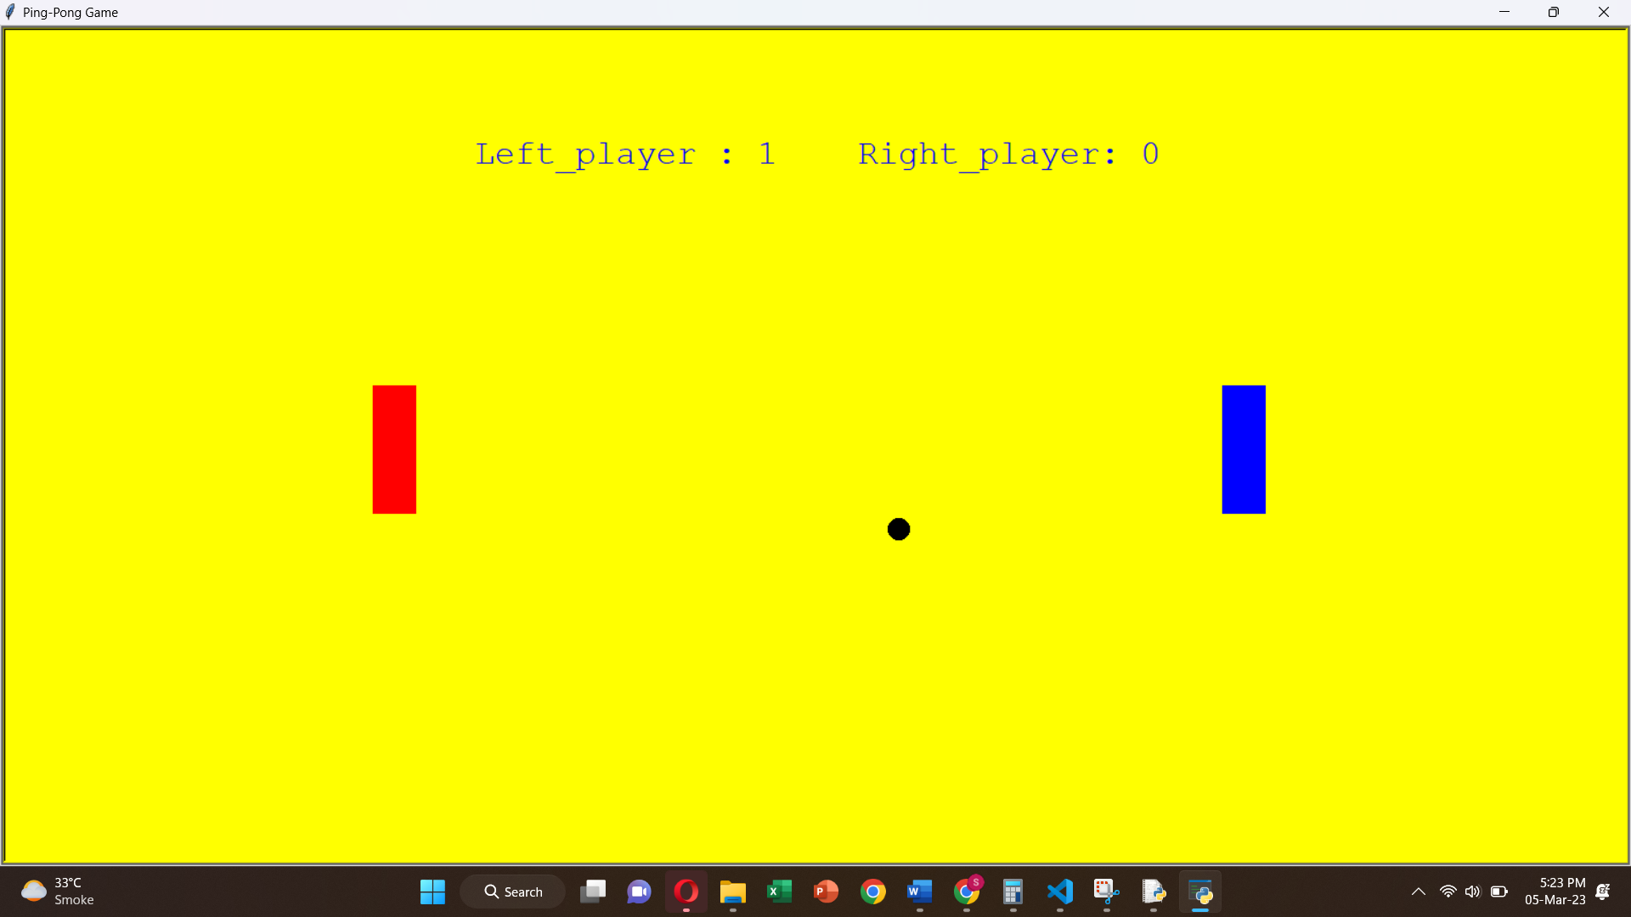

RULES FOR THE GAME AND HOW TO PLAY:

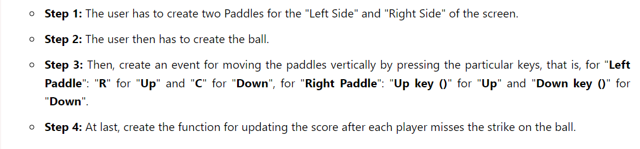

In the above code, after illustrating the outlook of the screen with paddles and ball, we will first initialize the score of both the players, that is, Zero. Then, we will display the score on the screen, which will increase with the opposite player missing the strike. We will then implement the functions for moving the paddle vertically. We will bind the keys for each function, that is, for "Left Paddle": "R" for "Up" and "C" for "Down", for "Right Paddle": "Up key" for "Up" and "Down key" for "Down". Then, we will initiate how the ball and striking of the paddle will work, as if the ball hit the paddle, it will go for the opposite player, but if the paddle missed the ball, then the ball will hit the border, and the opposite player will get the score. If the code is correct and no error is found, the screen of Ping Pong Game will pop up after running the code, and the players can play. The ball will first go for the right player.

THANKYOU